Week 1 ASSIGNMENT : POWER BI

**Exhaustive Analysis of Indian Agriculture**

* **Steps to get started with Power BI**

Step 1 : **Download and Install Power BI Desktop**

Step 2 : **Sign Up for Power BI Service**

Step 3 : **Open Power BI Desktop.**

Step 4 : **Click on BLANK REPORT**

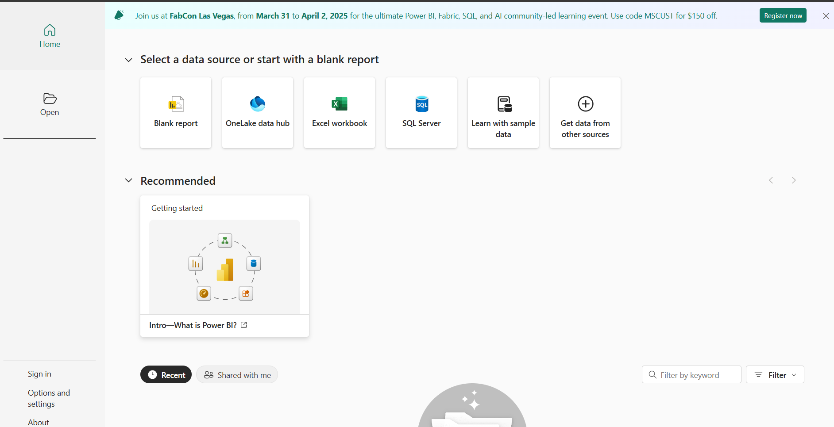

* **Go to “Get Data” and Open a File**

1.Click **"Get Data"** on the Home ribbon.

2. Select a data source from the list (e.g., Excel, CSV, SQL Server, Web, etc.).

3. If you have a local file choose **"Text/CSV"**, then click **"Connect"**.

4. Browse and open your file.

5. Preview the data, and load it into Power BI.

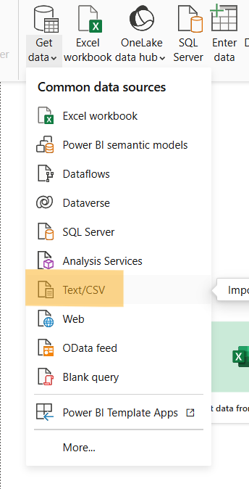 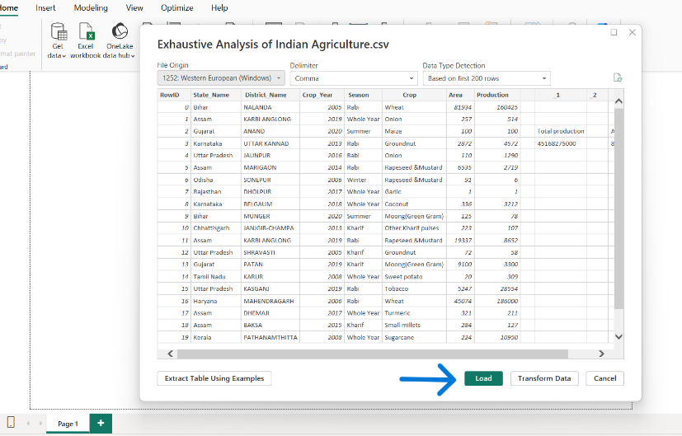

* **Transform and Clean Data**

Open the Power Query Editor by clicking "Transform Data".

Perform data cleaning tasks such as:

* Removing duplicates.
* Renaming columns.
* Changing data types.
* Filtering rows.

After cleaning, click "Close & Apply" to return to the Report View.

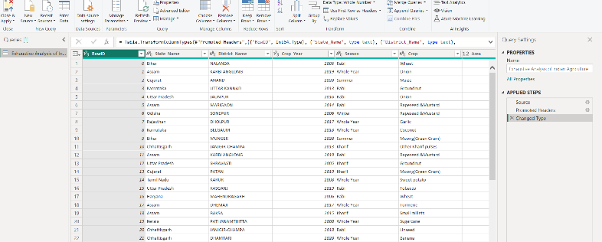

* **Steps to Remove an Empty Row**

1. **Right-Click to Remove the Row**
   * In Power Query Editor, locate the empty row in your dataset.
   * Right-click on the row and select the **"Remove Rows"** option from the menu. This will delete the selected row.
2. **Undo the Action (If Needed)**
   * If you want to undo this step, go to the **"Applied Steps"** pane on the right side of the Power Query Editor.
   * Find the step labeled **"Removed Rows"** and click the **X** icon next to it. This will remove the action and restore the deleted row.
3. **Save Your Changes**
   * Once you're satisfied with the data cleaning, click **"Close & Apply"** in the toolbar to apply the changes and return to Power BI Desktop.

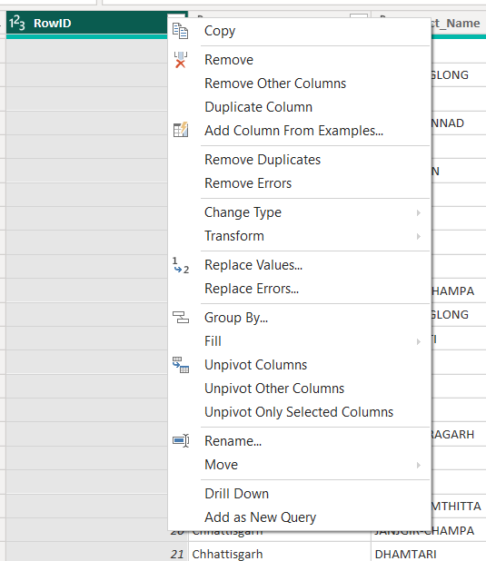

* **Steps to Remove a Column in Power BI**

1. **Right-Click to Remove a Column**
   * In Power Query Editor, locate the column you want to remove.
   * Right-click on the column header and select **"Remove"** from the context menu. This will delete the column from the dataset.
2. **Undo the Action (If Needed)**
   * To undo this step, go to the **"Applied Steps"** pane on the right side of Power Query Editor.
   * Look for the step labeled **"Removed Columns"** and click the **X** icon next to it. This will undo the column removal and restore the column to your dataset.
3. **Save Your Changes**
   * Once you’ve finalized the column removal, click **"Close & Apply"** in the toolbar to save the changes and return to Power BI Desktop.

* **View Tab**
* Location: Found on the ribbon in Power BI Desktop.
* Purpose: Allows you to customize the workspace appearance and easily switch between the three main views: Report, Data (Table), and Model.

1. **Report View**

**Purpose:** The main interface for creating and designing reports.

**Key Features :**

* 1. We perform **all the visualizations** here, such as charts, graphs, maps, and slicers.
  2. Drag and drop fields from the **Fields pane** into visuals to create interactive reports.
  3. Use the **Format pane** to style and customize visualizations (e.g., colors, labels, and fonts).
  4. Add calculated measures or columns using DAX to enhance visual insights.

**2. Table View**

* **Purpose:** Provides a tabular **overview of the data** that has been loaded into Power BI.
* **Key Features:**
  + Inspect tables, rows, and columns to verify the data.
  + View how transformations in Power Query are reflected in the tables.
  + Add **calculated columns** or fields to enhance the dataset.
  + This view does not support visualization creation but focuses on the underlying data.

3. **Model View**

* **Purpose:** Used for **joining and creating relationships between two or more files (tables)**.
* **Key Features:**
  + Display tables as entities and visualize the relationships between them.
  + Create and manage relationships by dragging and dropping fields between tables.
  + Configure **relationship cardinality** (one-to-one, one-to-many) and cross-filter directions.
  + Optimize and organize your data model for better performance and accuracy.

